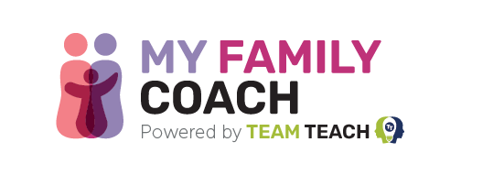
Introducing My Family Coach: Find the answers to your child’s behaviour

Dear Parents and Carers,
We’ve heard from countless families telling us about their struggle to find reliable and useful advice to understand children’s behaviour. At Team Teach, we have 20 years’ experience transforming 5,000 schools, and training over 100,000 people each year. We’ve now launched a free website called My Family Coach to help families.
My Family Coach is full of useful resources, produced by experts in child behaviour, parenting, and education. There’s over 13 hours of free support - and we’re adding more all the time.
You’ll enjoy:
- Quick Reads full of practical advice on a wide range of topics
- Bite-sized podcast episodes discussing children’s behaviour, to listen to on the go
- Video Talks offering expert advice on the issues affecting you
- Our free journal app to record, track and solve challenging behaviour, with 130+ helpful hints and tips
We also offer specialised support when you need it:
- Bookable online classes from our behaviour experts
- A wide range of online courses covering specific challenges
- 1:1 online coaching sessions
After the disruption of COVID-19, we’re finding so many children struggling with increased levels of anxiety, and families trying to cope with the behaviours that brings. We’re here to help.
My Family Coach gives you practical advice on a range of popular topics with expert insights into what your child’s behaviour is telling you. It helps you understand the reason behind behaviour that challenges, reduces arguments, and improves how your family communicates with each other.
It’s free and simple to register.
Sign up and find out what My Family Coach has to offer. You can find us at: MyFamilyCoach.com
Kind regards,

Jonathan Newport
Family Behaviour Specialist
My Family Coach is brought to you by Team Teach, award-winning positive behaviour training for schools and health and care settings.

